Introducing the Green Excellence Awards

The Green Excellence Awards are new to 2022 and recognise current products, services or initiatives that empower consumers to make sustainable choices across categories including banking, insurance, superannuation, utilities, and appliances.

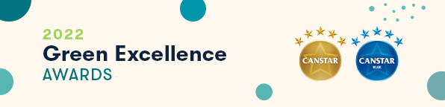
Submission Instructions
- Complete the Award Submission Form.
  - All submissions must be accompanied by a completed Submission Form (see below).
  - Only one submission form is required per initiative.
  - A new submission form is only required for additional initiatives, i.e., a company is submitting more than one initiative to the Awards.
- Include/attach any relevant supporting materials such as a short video, statistics or images that demonstrate the utilisation and impact of your initiative.
- Email submission to updates@canstar.com.au
  - Please use the following subject line format:
Canstar Green Excellence Award {Insert Initiative/Product/Service Name}
- Submission deadline is Friday 11th February 2022.
- Please note: The Judges’ decision is final, and no correspondence will be entered into.

Contact
For further information on the Awards or the submission process, please contact updates@canstar.com.au:
Erin Jackson  Primary Analyst | Melissa Martens  Team Lead

Award Submission Form

Please complete the following and include in your submission.

AWARD DETAILS

Please indicate (X) in the 1st column the category/categories that best describe your submission:
Appliances
Energy
Financial Products and Services
Telecommunications
Unsure/Other (please specify):

CONTACT INFORMATION
Institution:
Product/Service Name:
Initiative Inception Date:
Contact Person:
Contact Details:

Submission
Please include your submission below (4 pages or less recommended).

- Initiative Overview (word limit: 200)
Please provide an overview of the product, service or initiative.
- Outline how this product, service or initiative strives towards sustainability goals or empowers consumers to increase their personal sustainability.
Some examples may include deposits linked to sustainable outcomes, incentives/discounts for sustainable purchases or behaviour, carbon neutral products, climate positive investments or products that reduce/eliminate emissions, waste, or pollutants.
- Provide evidence that demonstrates the product, service or initiative’s utilisation and impact.
Utilisation and impact refers to how customers use or engage with the product, service or initiative, or how consumer behaviour is being reshaped.
Examples of evidence might include customer engagement insights or customer feedback (e.g., customer satisfaction, reviews or NPS).
- Outline any sustainability targets the product, service or initiative is trying to achieve and provide evidence of the current performance of the product, service or initiative at reaching these targets.
Examples of such targets might include emission reduction, renewable energy sources, value of loans issued to support sustainable product upgrades, and external benchmarks/accreditation.
- Provide evidence that demonstrates the business’ commitment to driving sustainable change.
Examples might include demonstrating the tangible business value created by the product, outlining funding or resource allocation by the business, or providing evidence of public-facing information, documentation and/or certifications.
- Outline any conditions, eligibility requirements, fees or costs that are attached to the product, service or initiative.
If applicable, what are the ongoing costs incurred for customers? Are there any upfront or exit fees? Do customers need to meet a minimum level of eligibility?

